**Project Design Phase-II**

**Data Flow Diagram & User Stories**

|  |  |
| --- | --- |
| Date | 19 JUNE 2025 |
| Team ID | LTVIP2025TMID33800 |
| Project Name | TrafficTelligence: Advanced Traffic Volume Estimation with Machine Learning |
| Maximum Marks | 4 Marks |

**Data Flow Diagrams:**

A Data Flow Diagram (DFD) is a traditional visual representation of the information flows within a system. A neat and clear DFD can depict the right amount of the system requirement graphically. It shows how data enters and leaves the system, what changes the information, and where data is stored.



**Example:** [**(Simplified)**](https://developer.ibm.com/patterns/visualize-unstructured-text/)

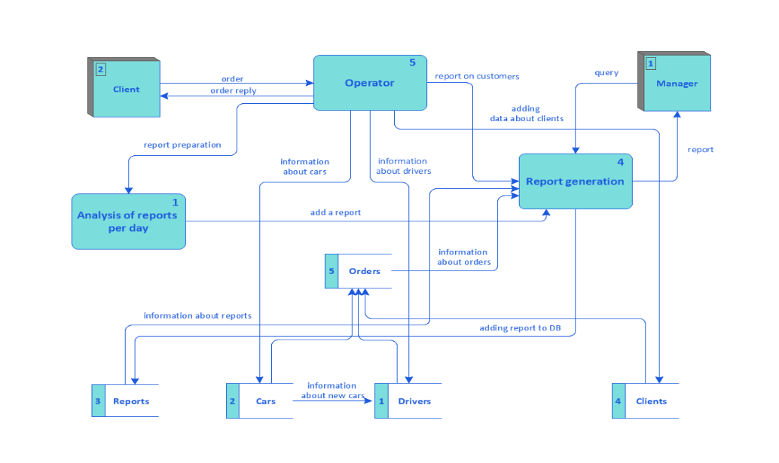

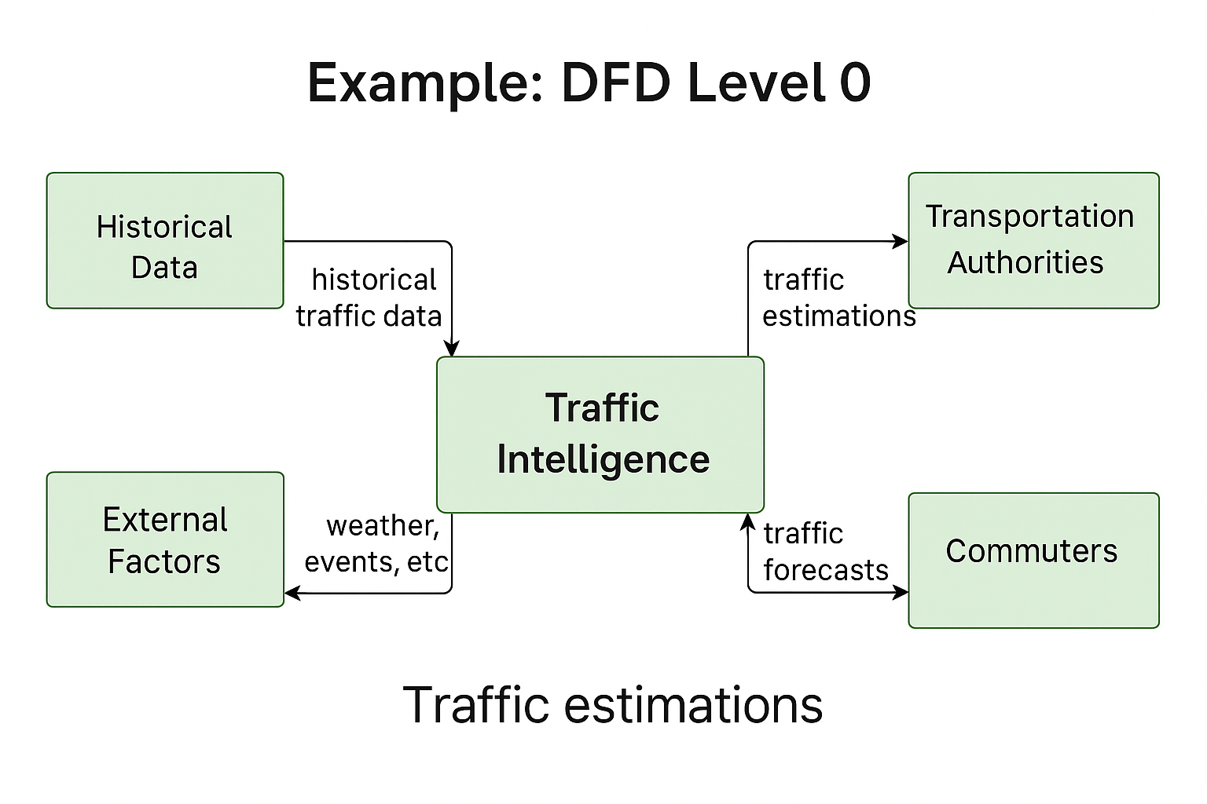

**User Stories**

Use the below template to list all the user stories for the product.

| **User Type** | **Functional Requirement (Epic)** | **User Story Number** | **User Story / Task** | **Acceptance criteria** | **Priority** | **Release** |
| --- | --- | --- | --- | --- | --- | --- |
| Data Engineer | Data Integration | USN-1 | As a developer, I want to train and validate a model to predict traffic volume | Data sources integrated and stored in raw form | High | Sprint-1 |
| Data Engineer | Data Preprocessing | USN-2 | As a developer, I want to evaluate model performance using test data and metrics | Dataset is cleaned, transformed, and ready for modeling | High | Sprint-1 |
| ML Engineer | Model Building | USN-3 | As a developer, I want to deploy the trained model as a service for real-time predictions | Model trained and validated with >80% accuracy | Low | Sprint-2 |
| ML Engineer | Model Evaluation | USN-4 | As an admin, I want to access real-time and historical traffic data through a secure dashboard | Model achieves acceptable MAE/RMSE | Medium | Sprint-1 |
| DevOps | Model Deployment | USN-5 | As a developer, I want to deploy the trained model as a service for real-time predictions | Model accessible via API | High | Sprint-1 |
| Admin | Dashboard Access | USN-6 | As an admin, I want to access real-time and historical traffic data through a secure dashboard | Dashboard displays real-time predictions | High | Sprint-4 |
| City Planner | Urban Planning Insights | USN-7 | As a city planner, I want to visualize traffic trends to assist infrastructure decisions | Reports downloadable by region and date | Medium | Sprint-3 |
| Commuter | Route Optimization | USN-8 | As a commuter, I want suggested routes based on predicted traffic | Routes change based on live prediction data | Low | Sprint-4 |
| Third-party App | |  | | --- | | API Integration |  |  | | --- | |  | | USN-9 | As a developer, I want access to traffic prediction API for use in external apps | API returns responses <2s and supports authentication | High | Sprint-2 |